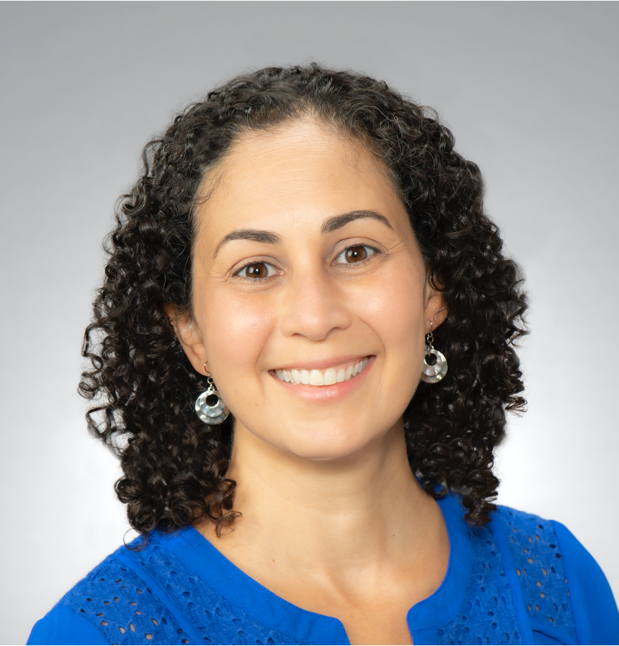

Erika Friehling, MD, MS is an associate professor of pediatrics at the University of Pittsburgh School of Medicine and Fellowship Program Director in the Division of Pediatric Hematology/Oncology. She is the Senior Associate Vice Chair of Faculty Affairs and Director of the Office of Faculty Development in the Department of Pediatrics.

Friehling received her Bachelor of Science degree from New York University, graduating *cum laude*. She received her Medical Degree from the University of Virginia School of Medicine in Charlottesville, Virginia having earned accolades including Alpha Omega Alpha, Gold Humanism Honor Society, and the Robert M. Blizzard Pediatric Scholar Award. Friehling then completed her pediatric residency training at UPMC Children’s Hospital of Pittsburgh and served as pediatric chief resident. She pursued subspecialty training in pediatric hematology/oncology at UPMC Children’s Hospital of Pittsburgh. Friehling was selected for the American Pediatric Association Educational Scholars Program and after completing the program received her Certificate of Excellence in Educational Scholarship. She also earned a Master of Science in Medical Education from the Institute for Clinical Research Education at the University of Pittsburgh.

Friehling has demonstrated a consistent focus on medical education throughout her career. She is a leader in the areas of faculty development, mentoring, and career advancement, presenting numerous workshops for faculty and trainees focused on these topics. Friehling leads the faculty mentoring program at Pitt Pediatrics. This important program involves the establishment of mentoring committees for all junior faculty. Her expertise in this area is recognized throughout the institution and nationally: she has been invited to speak on mentoring at the Academy of Master Educators, the Division of Urogynecology, the Department of Psychiatry, and the Department of Obstetrics and Gynecology.